11.82: a) Identifying x with 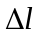in Eq. (11.10), 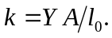
b) 